# 3.1 Literature Review – Variable Perturbation Size Adaptive P&O MPPT Algorithm for Sudden Changes in Irradiance

What particular issue of the MPPT has this paper addressed?

The core aim of any maximum power point tracking (MPPT) algorithm is to accomplish tracking that is both accurate and fast, whilst reducing any oscillations that may occur as a result of changes in weather conditions. The main issue that is addressed in this particular paper are the varying failures of the perturb and observe (P&O) method of MPPT. These issues arise when using a fixed perturbation size, as you are forced to make a trade-off between tracking accuracy and tracking speed. If you were to choose a large perturbation size the MPP will be reached much faster, but efficiency will be lost due to the fact of large fluctuations around the MPP, resulting in a large amount of wasted power. Whilst if you were to choose a small perturbation size the tracking accuracy of the MPP will be greatly improved, but it will take a long time to reach the MPP, resulting in a loss of power over the time taken to slowly attain the MPP.

*What is the algorithm of the proposed MPPT?*

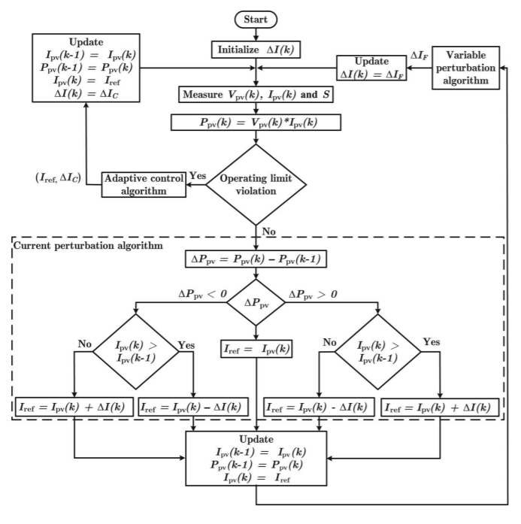

Figure 1: Flowchart of the proposed MPPT algorithm (Kollimalla & Mishra 2014)

The method proposed in this paper aims to overcome the shortcomings of the standard P&O method by using a combination of multiple algorithms. These three methods are adaptive control, variable perturbation and current perturbation algorithms. Seen above is the flowchart of this proposed algorithm designed by Sathish K. Kollimalla and Mahesh K. Mishra.

*How does this MPPT algorithm address the issue?*

This MPPT algorithms address the issue explained above through the combination of these three separate algorithms into a single method. The adaptive control algorithm (ACA) uses the idea behind the fractional short circuit current (FSCC) method. By multiplying the SCC with a constant of proportionality that has been created to obtain the MPP, the ACA is able to define an operating point that is close to the MPP given a change in conditions. The variable perturbation algorithm (VPA) is as it sounds, it is an algorithm designed to vary the size of perturbation depending on the proximity of tracking to the MPP. Whenever the operating point passes the MPP, the algorithm will reduce the size of perturbation in order to ensure that oscillations around the MPP are as small as possible. Finally, the current perturbation algorithm (CPA) simply follows the conventional P&O method however instead of using voltage perturbation, current perturbation is used. The intention behind this is to improve the speed of tracking of the MPP.

*What are the improvements shown from this MPPT?*

This method of MPPT shows a number of improvements over the conventional P&O method. Similarly to P&O, this method is able to securely track the MPP under standard conditions. However it is improved in the way that it is able to increase speed and improve performance under a “sudden violation of operating limits”, i.e. any changes in weather conditions. The dynamic perturbation size also speeds up the tracking of and improves the accuracy of the MPP where necessary. Overall, I believe this method of maximum power point tracking is far superior to the standard P&O methods used in our labs. As such, we have taken ideas from this paper in an attempt to implement a similarly functioning variable perturbation algorithm in our assignment.

*Any potential issue(s) with this proposed MPPT?*

I found it difficult to see many potential issues with the MPPT algorithm discussed in this paper. This is because it is able to track the MPP quite rapidly and accurately, with very small oscillations surrounding the maximum power point. It also excludes any complex computational efforts that are required in other methods of tracking due to the absence of derivatives, whilst not requiring storage for large amounts of data. However, I do believe that one issue with this proposed MPPT algorithm could stem from its complexity. By combining three different algorithms into a single method of maximum power point tracking, there is an increased risk of failure in any one of the algorithms which could negatively impact its performance. I believe that this level of complexity could also make it difficult for the algorithm to be implemented on a large scale without the help of professionals and engineers.

# 3.4 Conclude design and feedback

In the end, our design ended up being a very simple improvement to the original P&O algorithm from lab 4. We introduced a variable perturb size that allowed us to reach the MPP much faster than the generic P&O method. By taking 5% steps in duty cycle when the operating point is far from the MPP, and then reducing the steps back to 1% when close to the MPP we have been able to maintain the accuracy of the P&O method from lab 4 whilst greatly increasing the acquisition speed of the maximum power point. Below are some screenshots of how our algorithm tracks the MPP using this variable perturbation method.

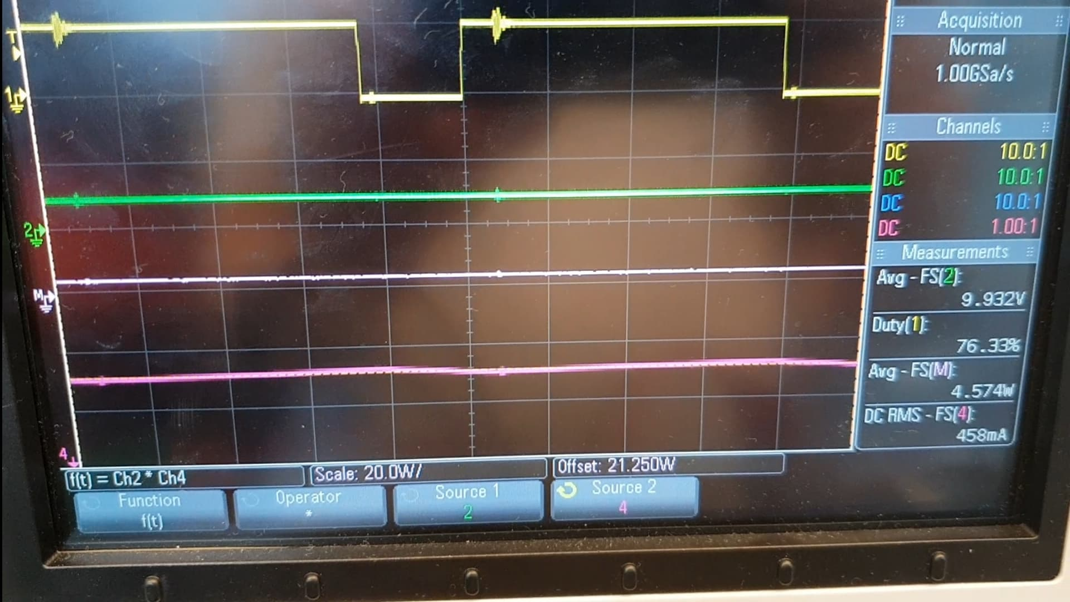

Figure 2: Frame 1 of MPPT algorithm

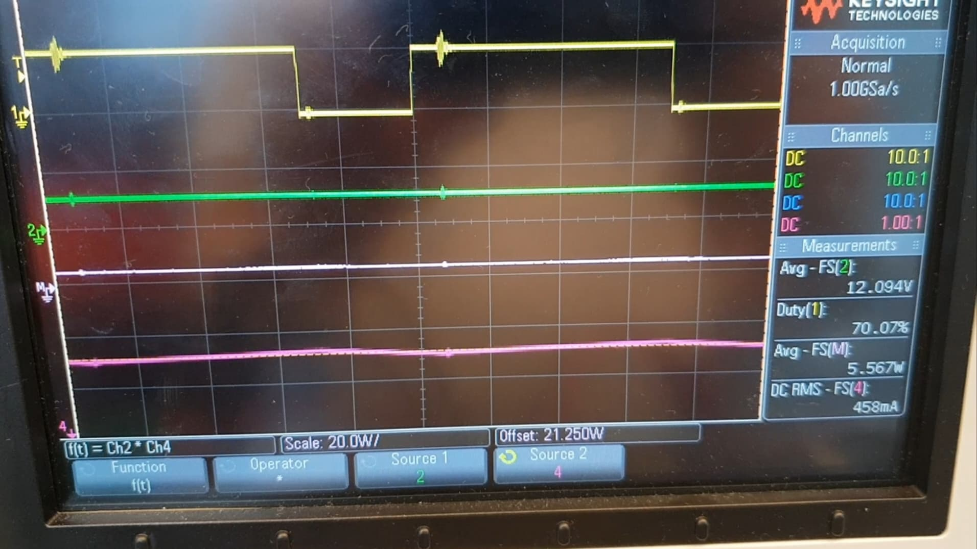

Figure 3: Frame 2 of MPPT algorithm

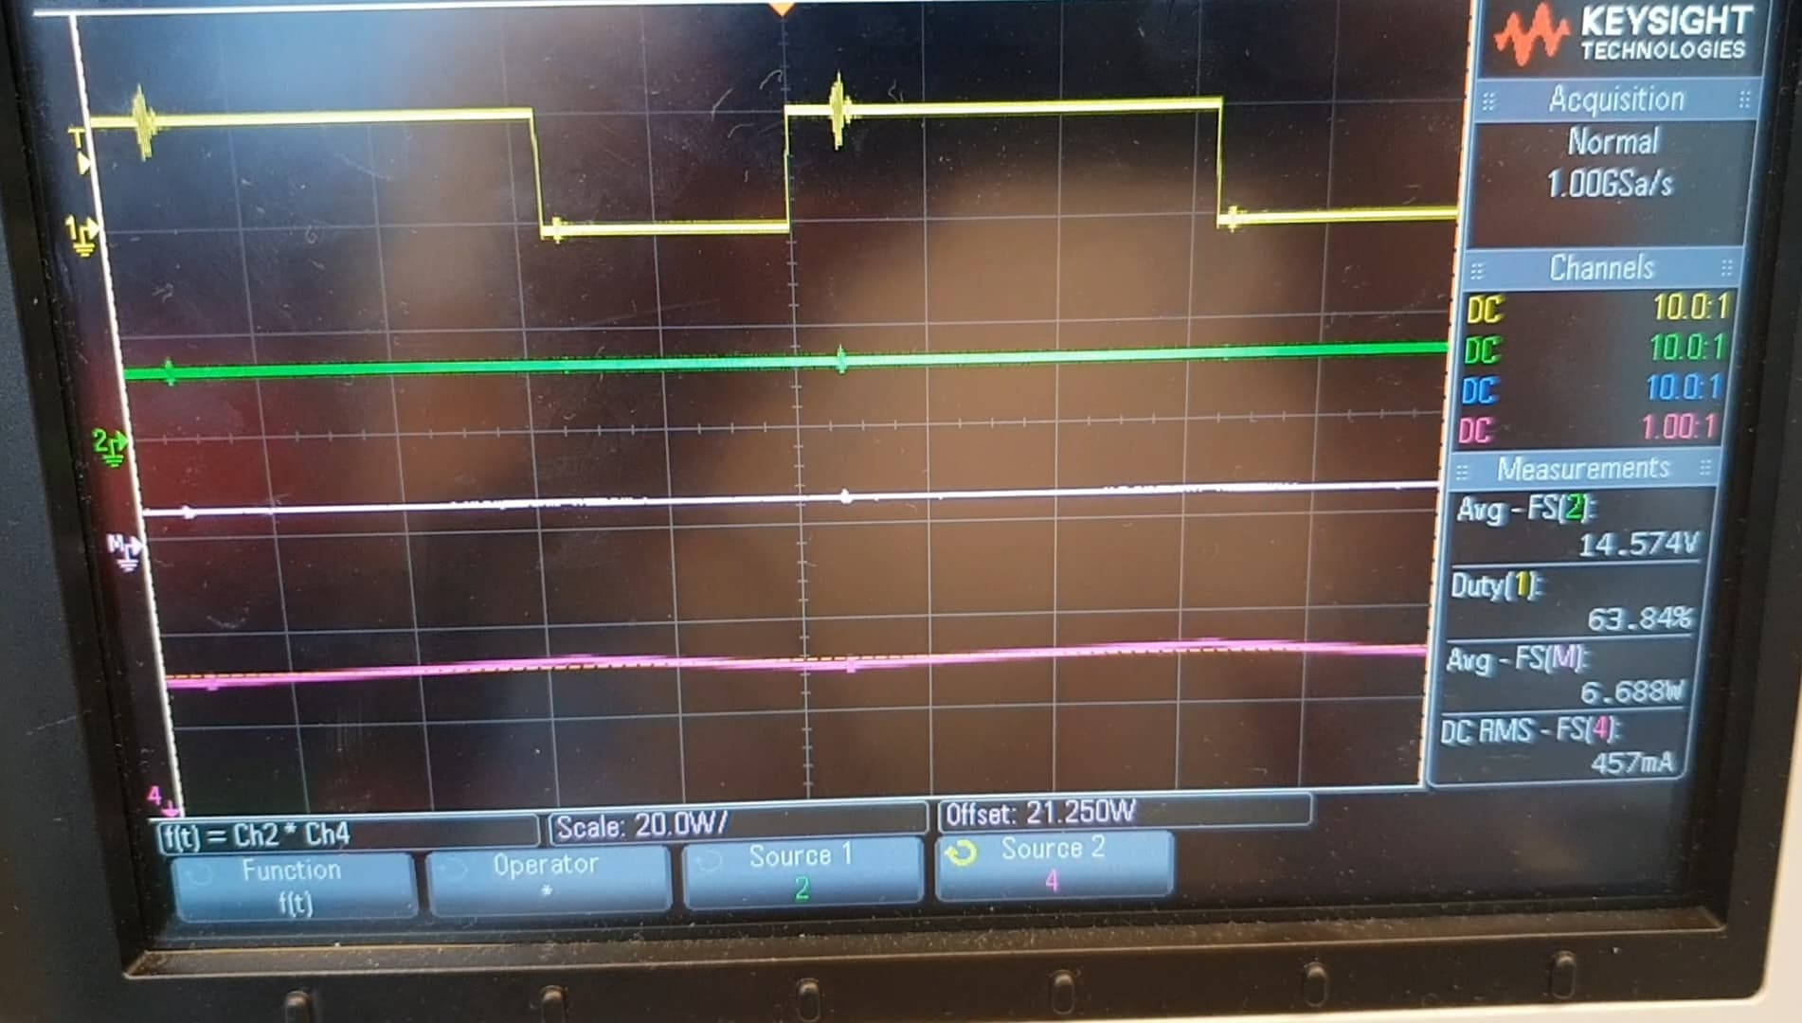

Figure 4: Frame 3 of MPPT algorithm

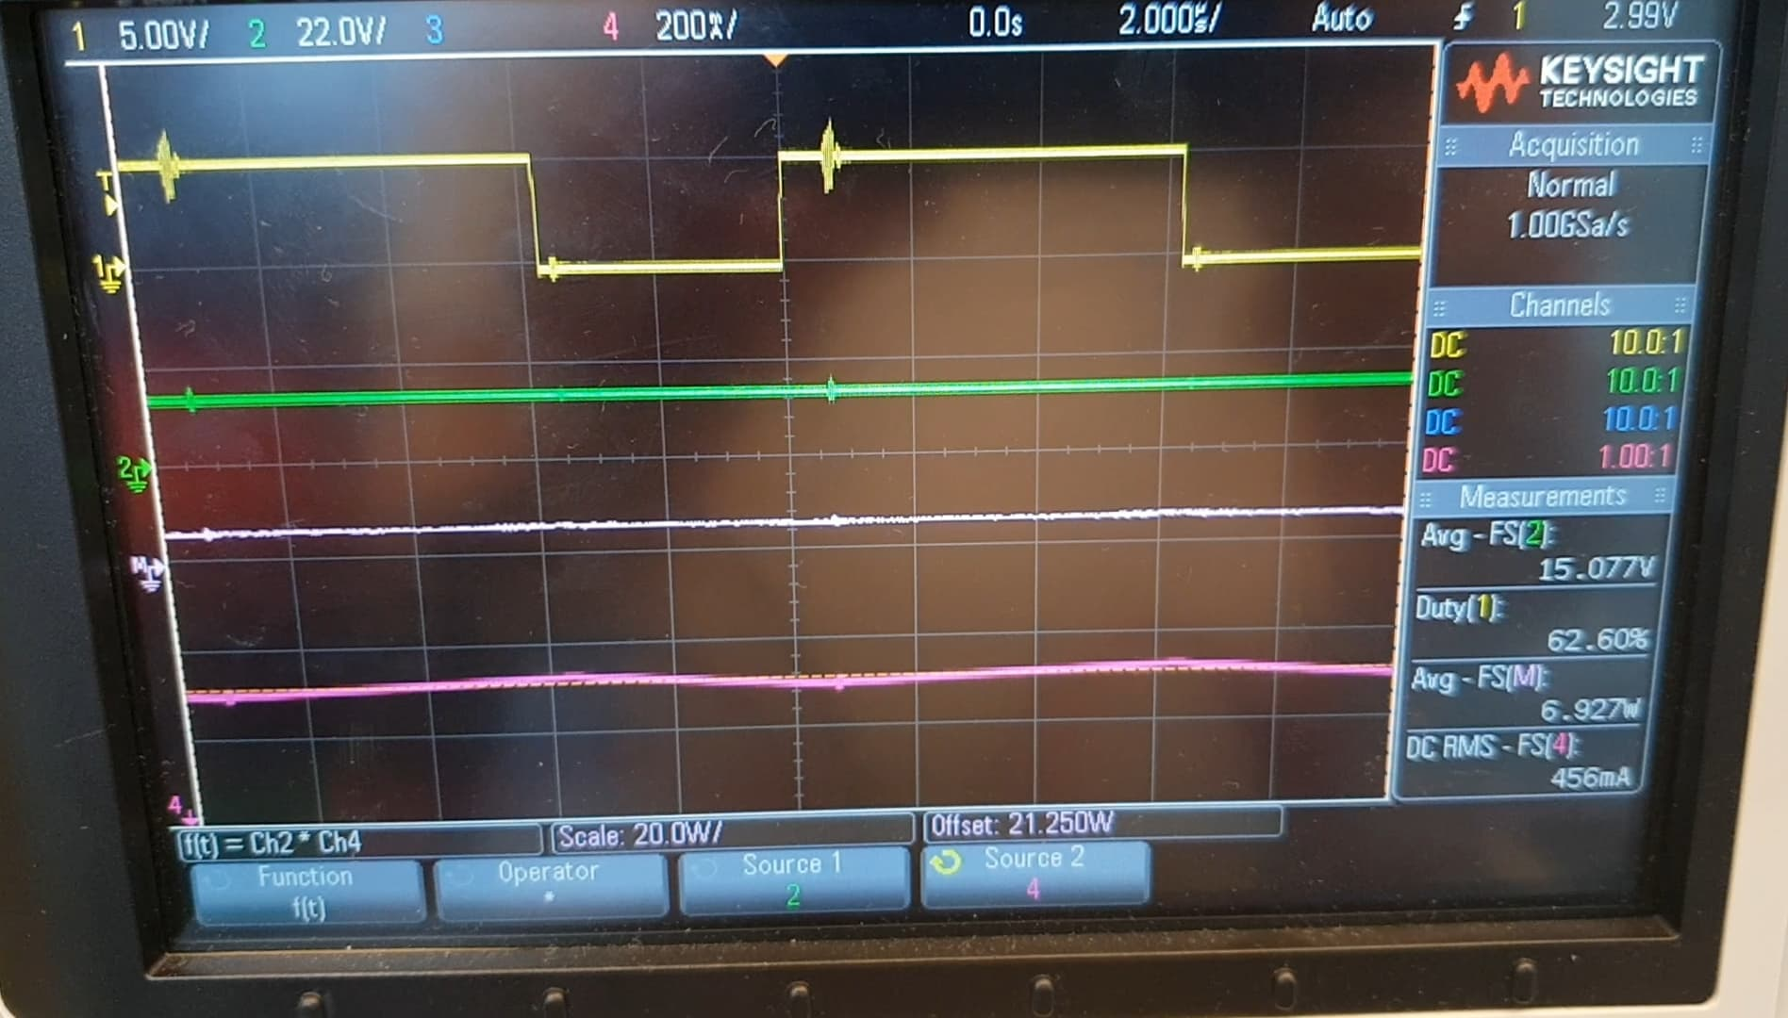

Figure 5: Frame 4 of MPPT algorithm

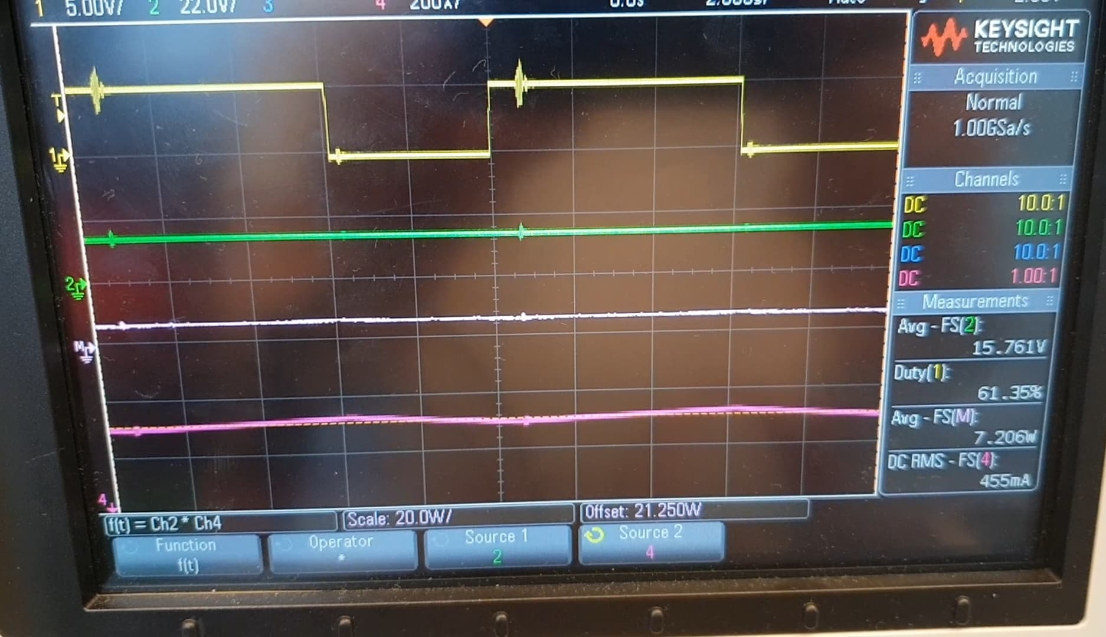

Figure 6: Frame 5 of MPPT algorithm

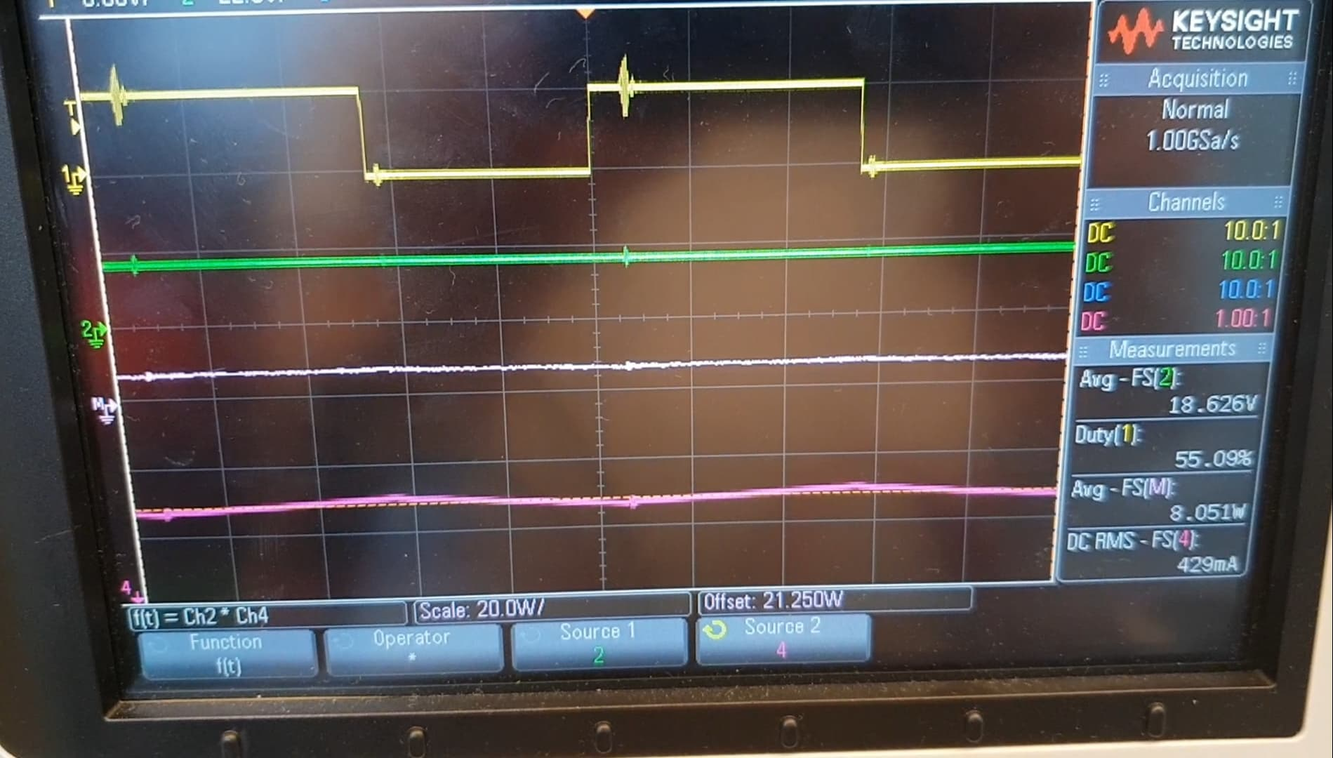

Figure 7: Frame 6 of MPPT algorithm

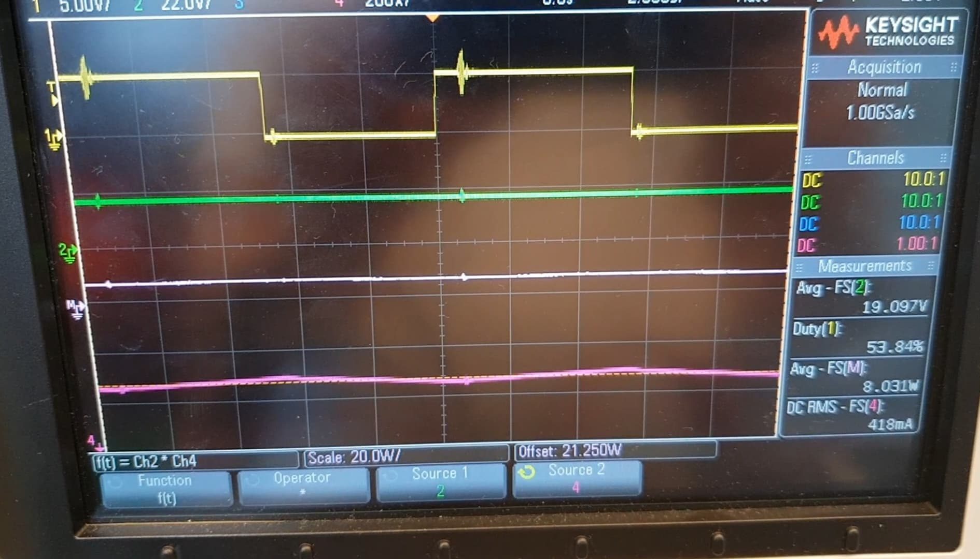

Figure 8: Frame 7 of MPPT algorithm

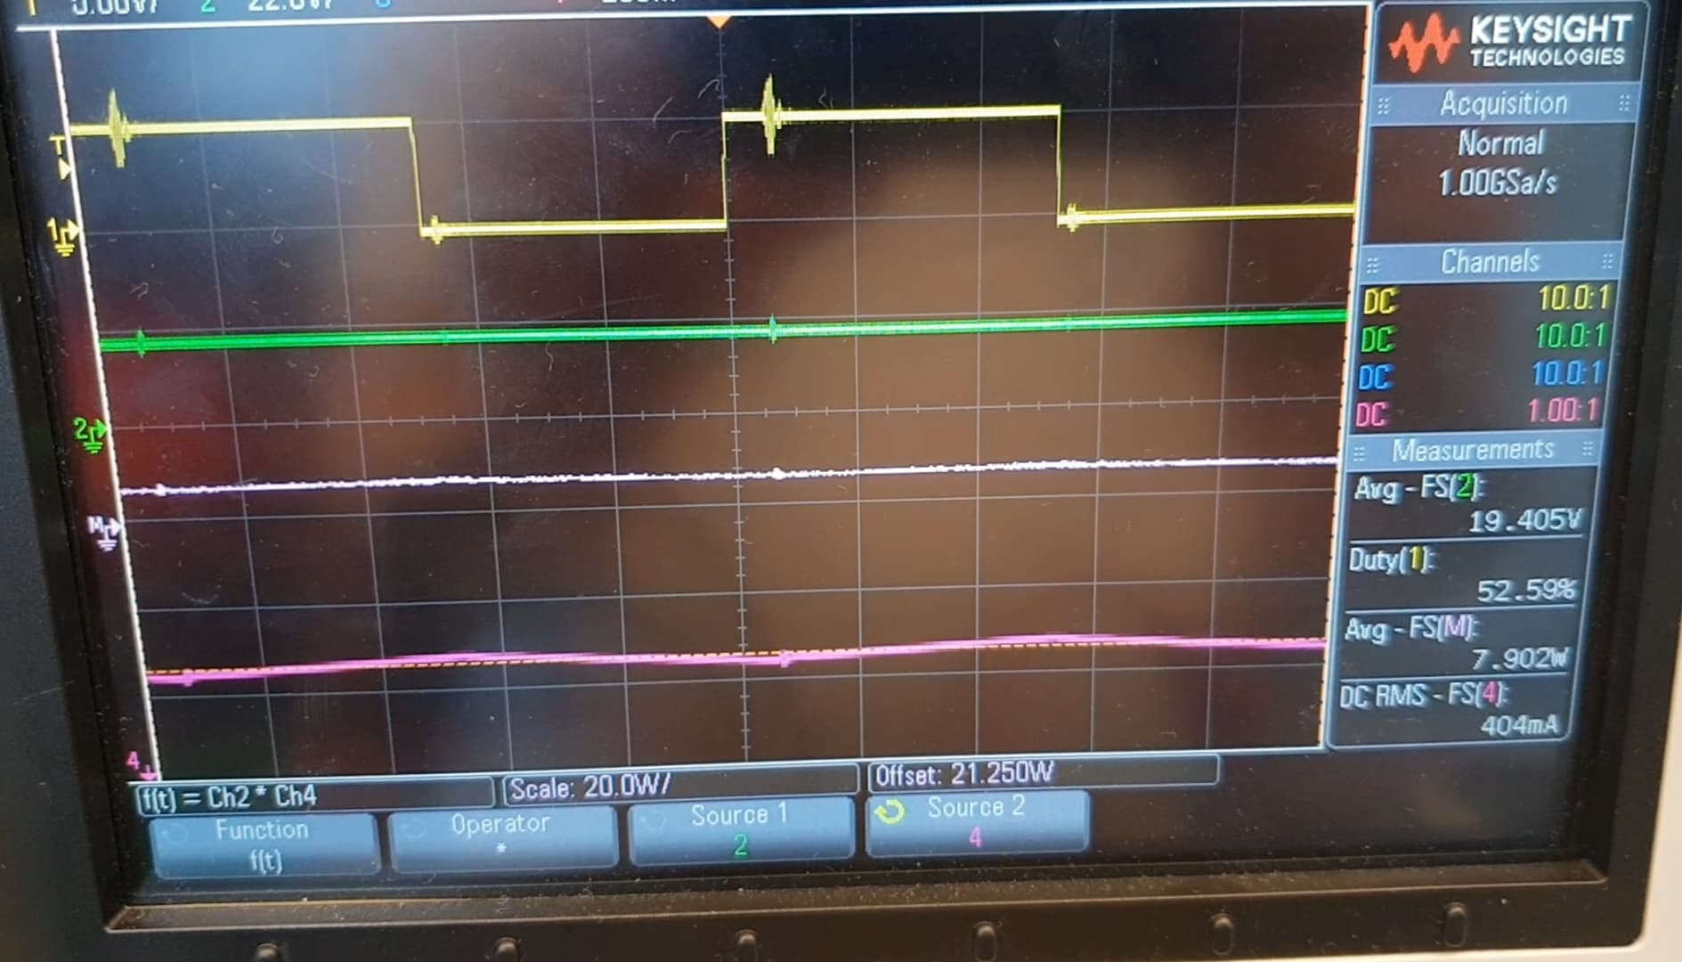

Figure 9: Frame 8 of MPPT algorithm

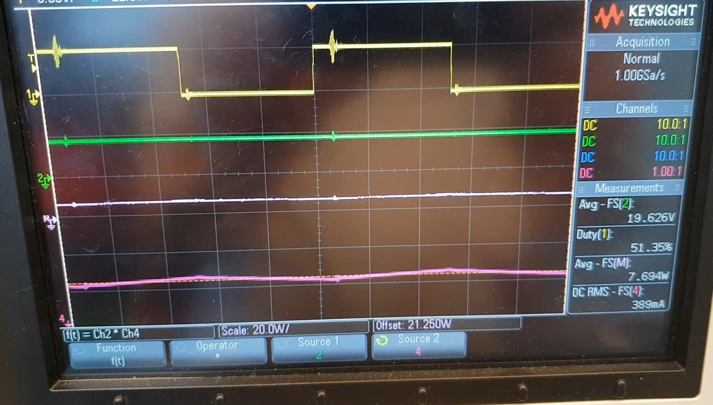

Figure 10: Frame 9 of MPPT algorithm

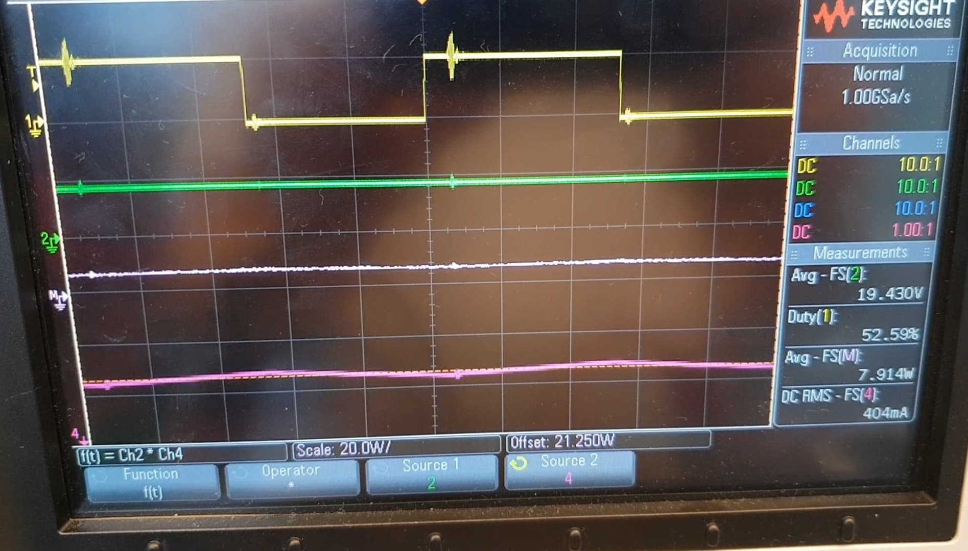

Figure 11: Frame 10 of MPPT algorithm

As can be seen in the above screen captures, the code allows for multiple 5% changes in duty cycle allowing for the MPP to be acquired much faster, before settling at around a 52% duty cycle. During the labs we measured the time taken for our new algorithm to settle at the MPP vs. the P&O method from lab 4. In the case of the images above, it took our algorithm roughly 15 seconds to reach 52% duty cycle from around 75% duty cycle, whereas these same values took the P&O method from lab 4 roughly 45 seconds. This makes the improved P&O with variable perturbation size 3x faster to reach the MPP (in this particular scenario) and thus more efficient due to the fact that more time is spent at the MPP.

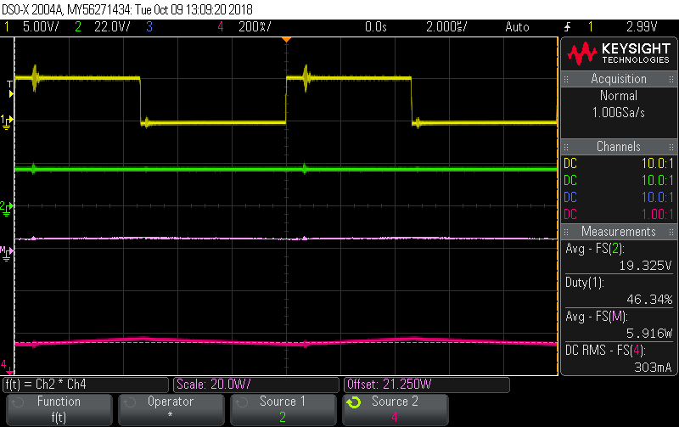

Figure 12: MPP at 0.4 A current limit

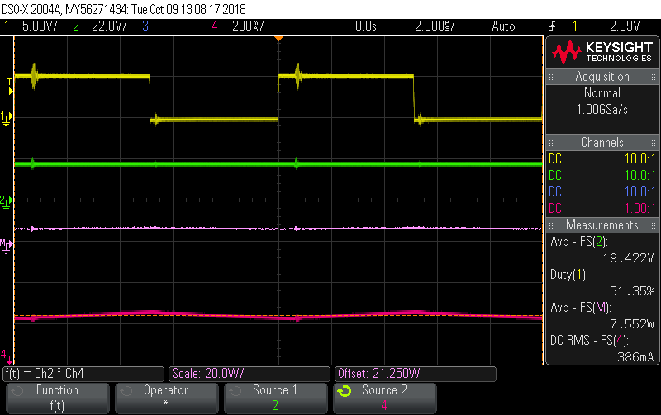

Figure 13: MPP at 0.5 A current limit

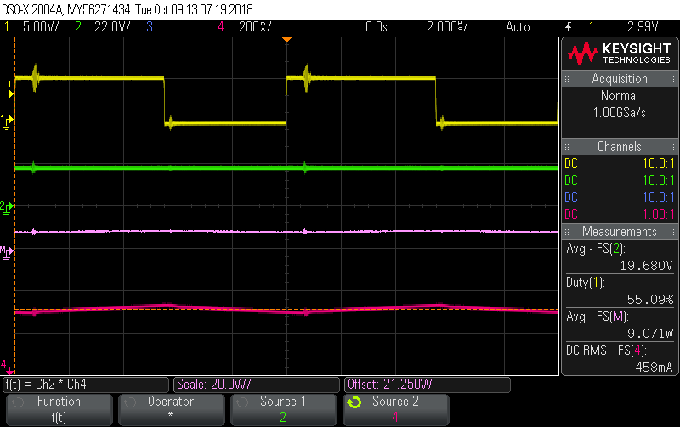

Figure 14: MPP at 0.6 A current limit

Above are screenshots of the MPPs at which the algorithm settles for current limits 0.4, 0.5 and 0.6 A. We also timed how long it took the improved algorithm to settle given changes in current limits in order to imitate a sudden change in irradiance. In the majority of circumstances our improved algorithm was faster than the regular P&O method, as most of the time there was a large enough step for the code to implement a 5% change in duty cycle. However in some circumstances no 5% step was taken, thus in these situations our improved method actually functioned the same as the P&O algorithm from lab 4. Despite this, we are still happy with our results as in the vast majority of situations our improved version proved to be faster and more efficient.

Overall we believe this project has provided a valuable learning experience. I believe each of our group members has taken away at least one piece of different information that will provide us with great benefit as future engineers. From research, to practical circuit building skills and applications we as aspiring engineers have all taken away vital information from this project. I believe that one thing we have all learned is how much time, effort and work can go into making even the smallest of improvements to something, as well as just how many engineers in the world are able to compose their own unique solutions to any given problem.

# References

Kollimalla, S. and Mishra, M. 2014, ‘Variable Perturbation Size Adaptive P&O MPPT Algorithm for Sudden Changes in Irradiance’, *IEEE Transactions on Sustainable Energy*, vol. 5, no. 3, pp. 718-728, <<https://ieeexplore-ieee-org.ezproxy.lib.uts.edu.au/stamp/stamp.jsp?tp=&arnumber=6732969&tag=1>>.